Consortium
For more information on the work packages (WP) cited below, see the project's agenda.

Laboratoire Interdisciplinaire des Sciences du Numérique
https://www.lisn.upsaclay.fr/
The LISN oversees the project's coordination under the responsibility of Pr. Nicolas Sabouret and brings competencies in all three domains of the project: human factors (HF), artificial intelligence (AI), and human-computer interaction (HCI).
For Human Factors, Dr. Ève Fabre leads the work in WP1 for the theoretical characterization of fixation biases and the design of the experimental protocol and scenarios. She also supervises the data collection at ONERA and UCBL. Dr. Céline Clavel studies the social and psychological acceptability of the virtual assistant (WP5). Ève Fabre and Céline Clavel are also responsible for analyzing the data in WP2 to characterize fixation errors from the Cognitive psychology point of view.
For Artificial Intelligence, Pr. Nicolas Sabouret works with LMF and Heudiasyc on WP3 to define a formal model of the task and mental states in the experimental scenarios, as well as new algorithms for human error diagnosis, that will be at the core of the AI assistant for fixation error detection.
For Human-Computer Interaction, Pr. Wendy Mackay supervises the design of the HCI models for the AI assistant throughout the project, and more particularly in WP4. She is assisted by three members of the ASARD team at LISN: Dr. Nicolas Ladeveze for eXtended Reality (XR) design, Laurence Bolot for HCI implementation and Cyril Verecchia for graphics design.
The LISN will also lead all coordination activities (WP7) and participate actively in all communication and dissemination activities (WP6).

Unité Heuristique et Diagnostic des Systèmes Complexes (Heudiasyc)
https://www.hds.utc.fr/
Heudiasyc has unique competencies in the design of Virtual Reality (VR) environments for training. This is why it is in charge of two main tasks in the IDEFIX project:
- The development of the VR medical environment used in the experiments in WP5;
- The design of new algorithms for situation control that allow the system to maintain participants in the required level of fixation error during training.
This work is done under the supervision of Pr. Domitile Lourdeaux.
Domitile Lourdeaux also works in close collaboration with Pr. Sylvain Lagrue, LISN and LMF on the design of the formal model for the AI assistant in WP3.

Laboratoire Méthodes Formelles
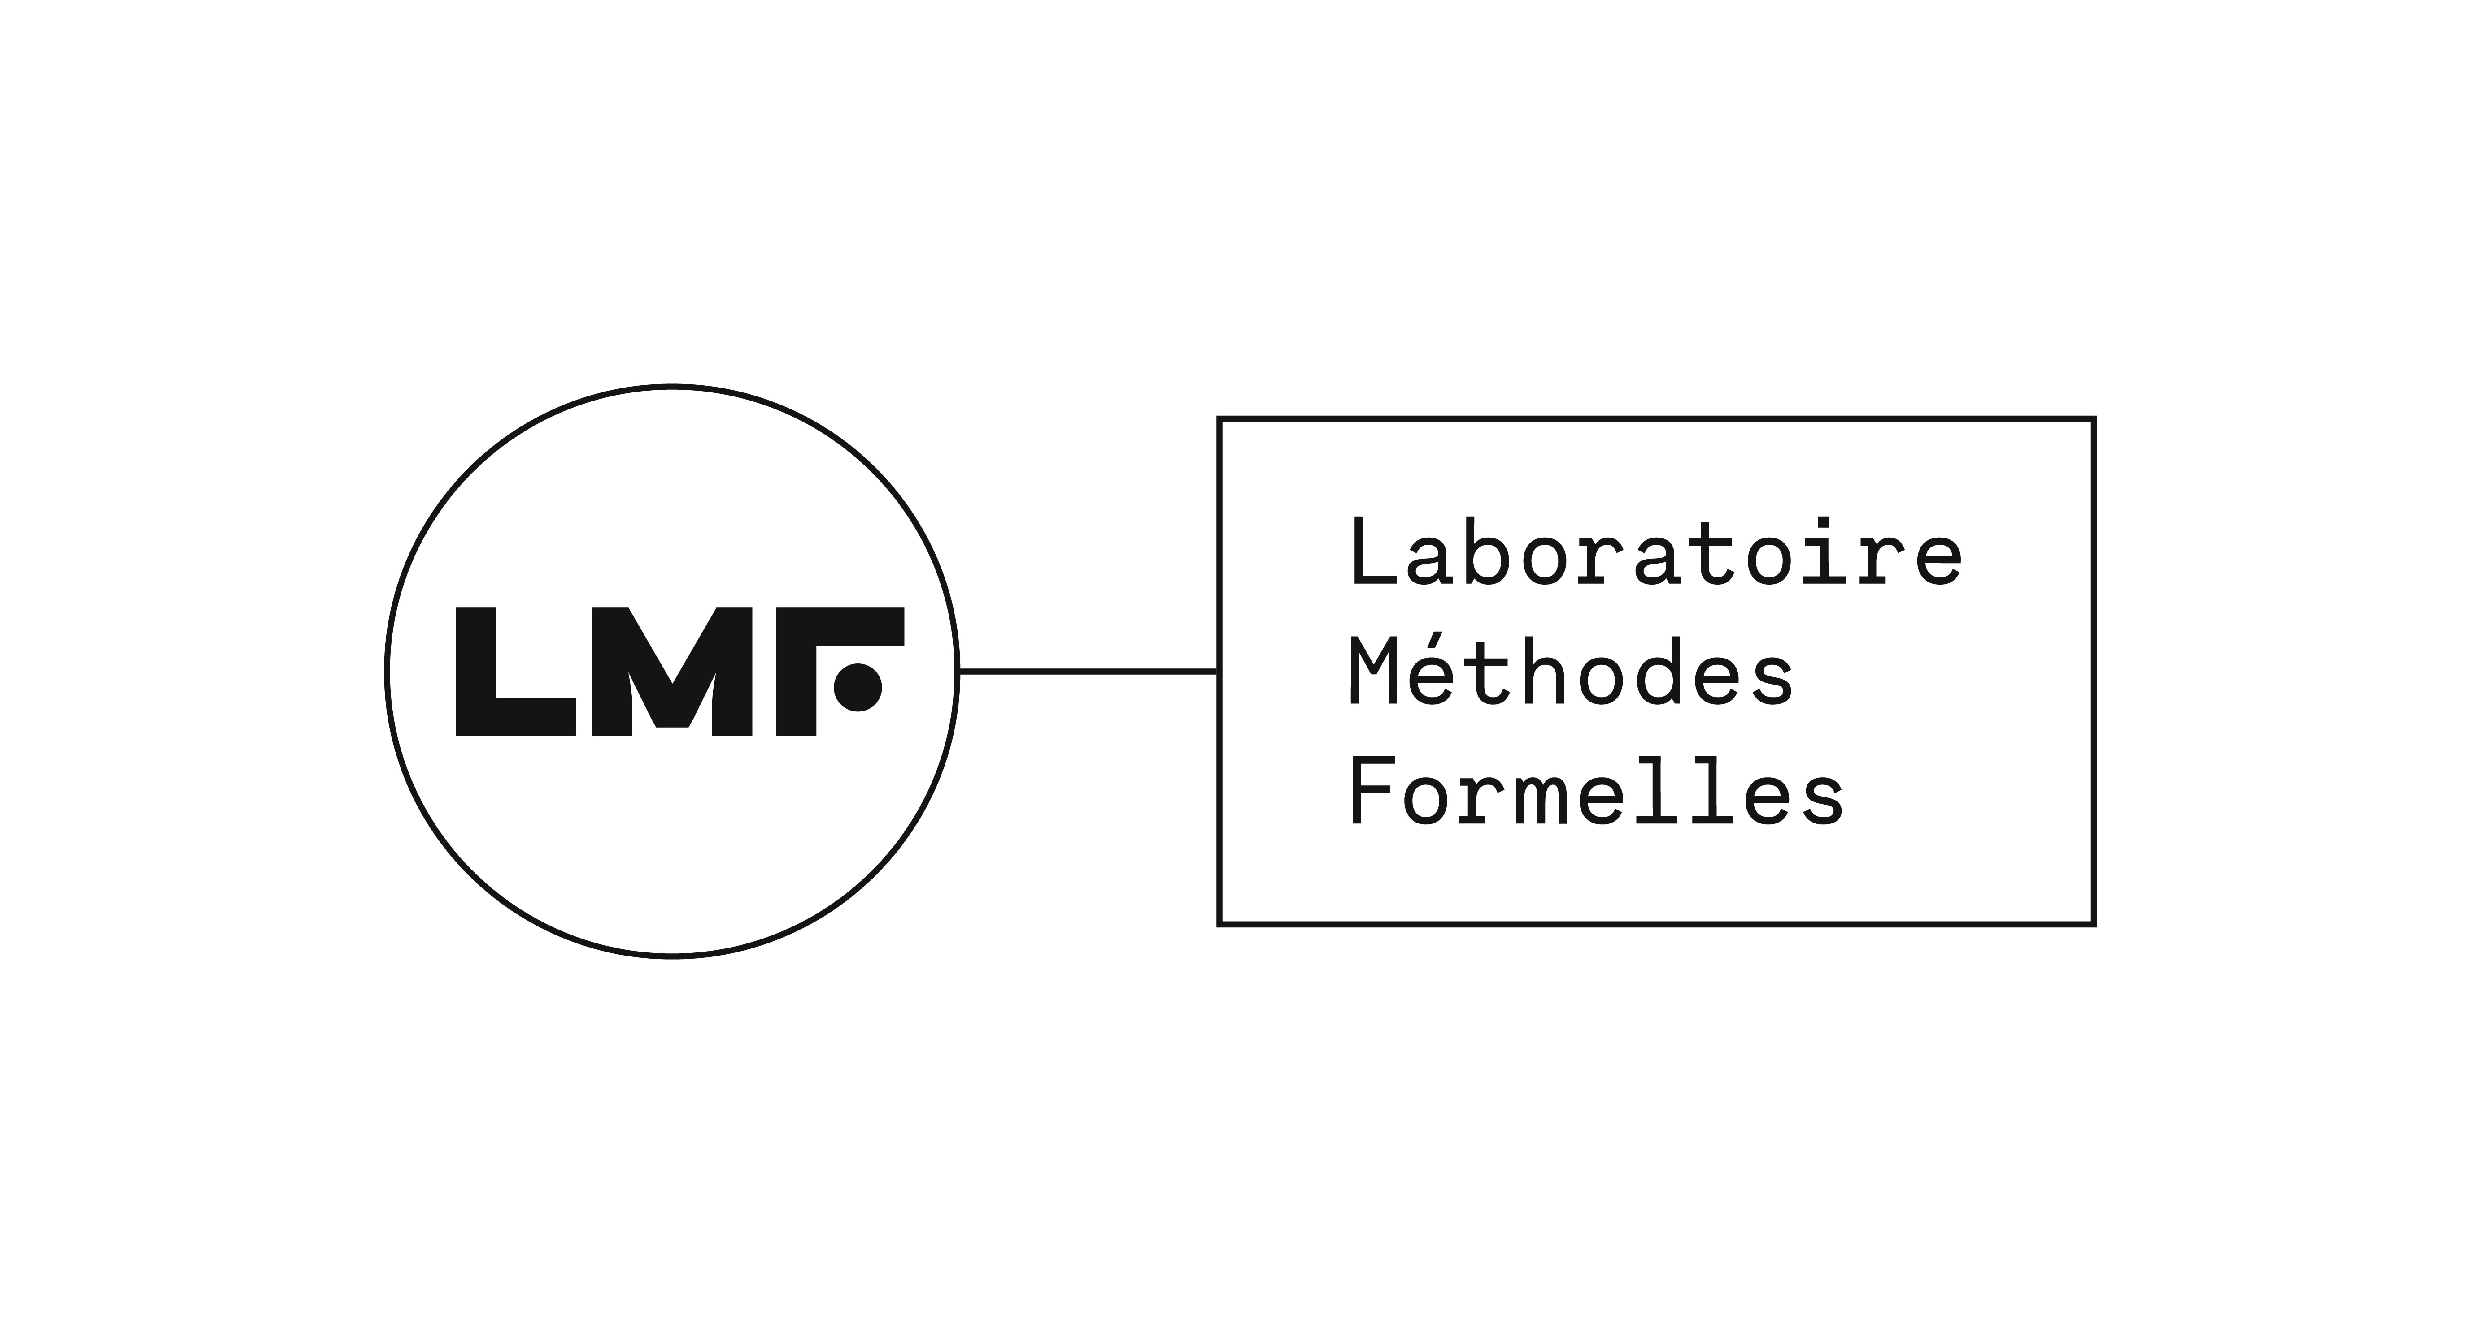https://lmf.cnrs.fr/
Under the supervision of Pr. Frédéric Boulanger, the LMF coordinates the research work on the formal model in WP3. Together with LISN and Heudiasyc, we will design:
- A new formal model of the task and mental states, based on previous joint work between LMF and LISN, that can capture fixation bias in the different scenarios of the IDEFIX project's experimental protocol;
- New algorithms for real-time human error diagnosis based on this formal model.

Département Traitement de l'Information et Systèmes (DTIS) de l'ONERA
https://www.onera.fr/fr/dtis-traitement-de-l-information-et-systemes
The DTIS conducts research in all fields of computer science related to aerospace. In the IDEFIX project, the team led by Dr. Bertille Somon in the cognitive engineering and applied neuroscience unit (ICNA) brings a unique expertise in cognitive neuroscience for the study and design of human factors and physiological data.
In the IDEFIX project, Bertille Somon collaborates closely with LISN on the design of the experimental scenarios (WP1). She will supervise the implementation of aviation scenario on the SCHEMAX flight simulator and ONERA, with the help of ONERA engineers Gregory Bonin], [[https://dblp.org/pid/30/507-3.html|Christian Schulte and Nawfel Kinani. They are also responsible for the integration of the AI assistant in the Augmented Reality (AR) aviation environment in WP4.
In addition, Dr. Nicolas Lantos brings his expertise on data science methods for fixation error detection at runtime. Based on the analysis of experimental data in WP2, he designs new models to extract high-level concepts that serve as inputs to the formal model of the AI assistant.

Université Claude Bernard Lyon

Institut de Recherche Biomédicale des Armées

