Agenda of the project
The project is organised with 7 workpackages:
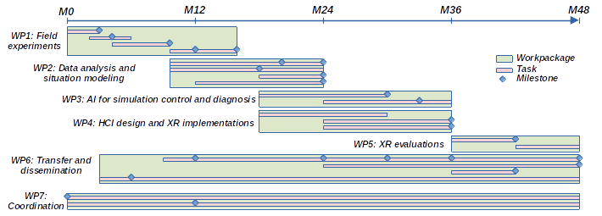

Workpackage 1

